vars n mean sd

X 1 13232 6616.50 3819.89

CityName* 2 13232 18.07 11.72

Population 3 13232 4416836.87 4258386.00

CityRank 4 13232 14.83 13.51

IsMetroCity 5 13232 0.28 0.45

IsTouristDestination 6 13232 0.70 0.46

IsWeekend 7 13232 0.62 0.48

IsNewYearEve 8 13232 0.12 0.33

Date* 9 13232 14.26 2.82

HotelName* 10 13232 841.19 488.16

RoomRent 11 13232 5473.99 7333.12

StarRating 12 13232 3.46 0.76

Airport 13 13232 21.16 22.76

HotelAddress* 14 13232 1202.53 582.17

HotelPincode 15 13232 397430.26 259837.50

HotelDescription* 16 13224 581.34 363.26

FreeWifi 17 13232 0.93 0.26

FreeBreakfast 18 13232 0.65 0.48

HotelCapacity 19 13232 62.51 76.66

HasSwimmingPool 20 13232 0.36 0.48

median trimmed mad min

X 6616.5 6616.50 4904.44 1.0

CityName* 16.0 17.29 11.86 1.0

Population 3046163.0 4040816.22 3846498.95 8096.0

CityRank 9.0 13.30 11.86 0.0

IsMetroCity 0.0 0.23 0.00 0.0

IsTouristDestination 1.0 0.75 0.00 0.0

IsWeekend 1.0 0.65 0.00 0.0

IsNewYearEve 0.0 0.03 0.00 0.0

Date* 14.0 14.39 2.97 1.0

HotelName* 827.0 841.18 641.97 1.0

RoomRent 4000.0 4383.33 2653.85 299.0

StarRating 3.0 3.40 0.74 0.0

Airport 15.0 16.39 11.12 0.2

HotelAddress* 1261.0 1233.25 668.65 1.0

HotelPincode 395003.0 388540.47 257975.37 100025.0

HotelDescription* 567.0 575.37 472.95 1.0

FreeWifi 1.0 1.00 0.00 0.0

FreeBreakfast 1.0 0.69 0.00 0.0

HotelCapacity 34.0 46.03 28.17 0.0

HasSwimmingPool 0.0 0.32 0.00 0.0

max range skew kurtosis

X 13232 13231.0 0.00 -1.20

CityName* 42 41.0 0.48 -0.88

Population 12442373 12434277.0 0.68 -1.08

CityRank 44 44.0 0.69 -0.76

IsMetroCity 1 1.0 0.96 -1.08

IsTouristDestination 1 1.0 -0.86 -1.26

IsWeekend 1 1.0 -0.51 -1.74

IsNewYearEve 1 1.0 2.28 3.18

Date* 20 19.0 -1.05 2.93

HotelName* 1670 1669.0 0.01 -1.25

RoomRent 322500 322201.0 16.75 582.06

StarRating 5 5.0 0.48 0.25

Airport 124 123.8 2.73 7.89

HotelAddress* 2108 2107.0 -0.37 -0.88

HotelPincode 7000157 6900132.0 9.99 249.76

HotelDescription* 1226 1225.0 0.11 -1.25

FreeWifi 1 1.0 -3.25 8.57

FreeBreakfast 1 1.0 -0.62 -1.61

HotelCapacity 600 600.0 2.95 11.39

HasSwimmingPool 1 1.0 0.60 -1.64

se

X 33.21

CityName* 0.10

Population 37019.65

CityRank 0.12

IsMetroCity 0.00

IsTouristDestination 0.00

IsWeekend 0.00

IsNewYearEve 0.00

Date* 0.02

HotelName* 4.24

RoomRent 63.75

StarRating 0.01

Airport 0.20

HotelAddress* 5.06

HotelPincode 2258.86

HotelDescription* 3.16

FreeWifi 0.00

FreeBreakfast 0.00

HotelCapacity 0.67

HasSwimmingPool 0.00

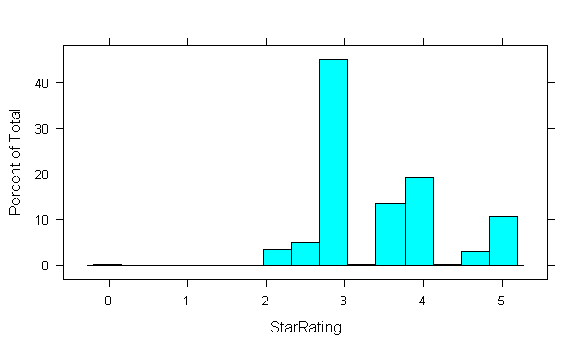

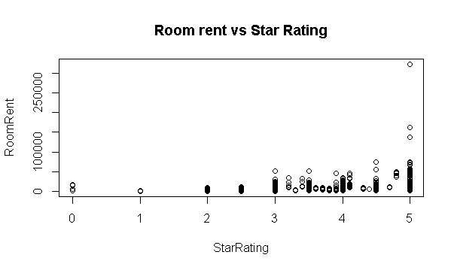

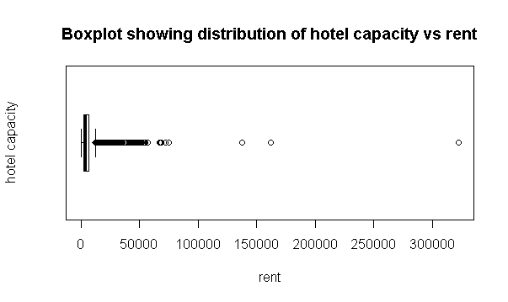

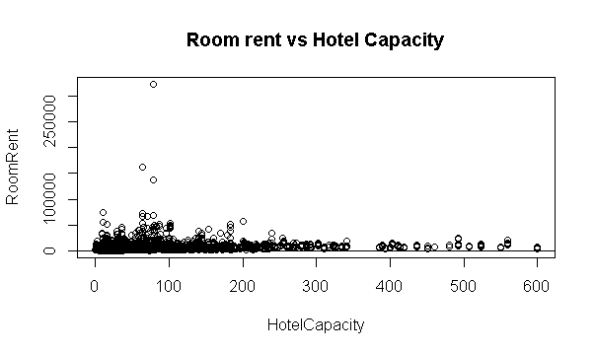

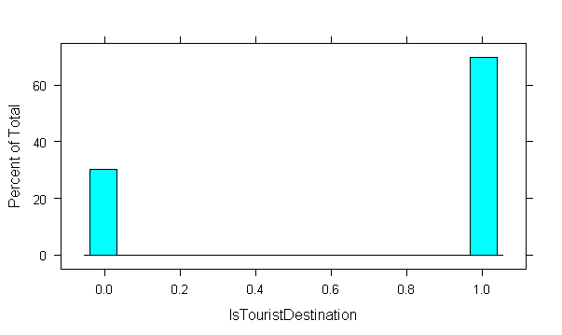

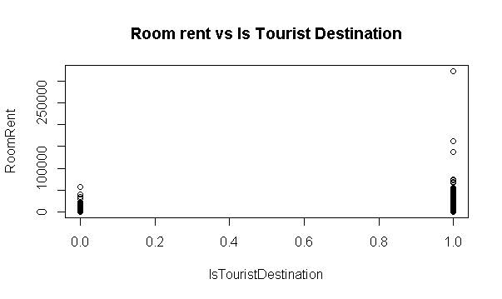

RoomRent IsTouristDestination HotelCapacity StarRating

RoomRent 1.00 0.12 0.16 0.37

IsTouristDestination 0.12 1.00 -0.09 -0.04

HotelCapacity 0.16 -0.09 1.00 0.64

StarRating 0.37 -0.04 0.64 1.00

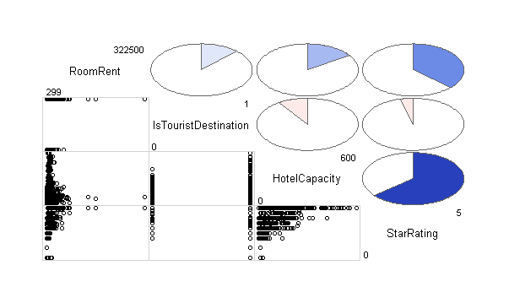

lm(formula = RoomRent ~ IsTouristDestination + HotelCapacity +

StarRating, data = training_set)

Residuals:

Min 1Q Median 3Q Max

-11023 -2483 -867 1003 309647

Coefficients:

Estimate Std. Error t value Pr(>|t|)

(Intercept) -10728.762 380.686 -28.18 <2e-16 ***

IsTouristDestination 2110.171 148.595 14.20 <2e-16 ***

HotelCapacity -11.503 1.139 -10.10 <2e-16 ***

StarRating 4476.120 116.171 38.53 <2e-16 ***

---

Signif. codes: 0 ‘***’ 0.001 ‘**’ 0.01 ‘*’ 0.05 ‘.’ 0.1 ‘ ’ 1

Residual standard error: 7045 on 10767 degrees of freedom

Multiple R-squared: 0.1578, Adjusted R-squared: 0.1576

F-statistic: 672.5 on 3 and 10767 DF, p-value: < 2.2e-16

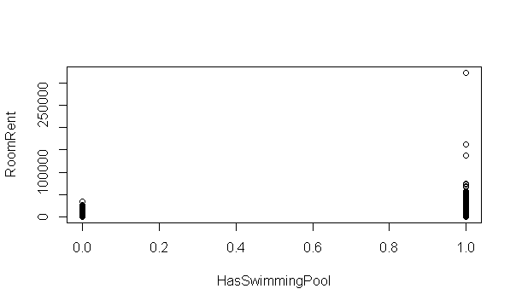

Call:

lm(formula = RoomRent ~ HotelCapacity + HasSwimmingPool + FreeWifi +

FreeBreakfast, data = training_set)

Residuals:

Min 1Q Median 3Q Max

-8043 -2286 -1135 775 313879

Coefficients:

Estimate Std. Error t value Pr(>|t|)

(Intercept) 3469.0712 274.6649 12.630 <2e-16 ***

HotelCapacity -0.1026 1.0575 -0.097 0.923

HasSwimmingPool 4892.9420 171.1561 28.588 <2e-16 ***

FreeWifi 267.1570 272.2799 0.981 0.327

FreeBreakfast 100.4281 150.2517 0.668 0.504

---

Signif. codes: 0 ‘***’ 0.001 ‘**’ 0.01 ‘*’ 0.05 ‘.’ 0.1 ‘ ’ 1

Residual standard error: 7312 on 10766 degrees of freedom

Multiple R-squared: 0.09281, Adjusted R-squared: 0.09248

F-statistic: 275.4 on 4 and 10766 DF, p-value: < 2.2e-16

Call:

lm(formula = RoomRent ~ IsTouristDestination + IsWeekend + IsNewYearEve +

IsMetroCity, data = training_set)

Residuals:

Min 1Q Median 3Q Max

-6922 -2936 -1321 1033 315968

Coefficients:

Estimate Std. Error t value Pr(>|t|)

(Intercept) 4321.48 166.58 25.943 < 2e-16 ***

IsTouristDestination 2244.22 161.87 13.864 < 2e-16 ***

IsWeekend -33.82 157.85 -0.214 0.83035

IsNewYearEve 739.33 232.03 3.186 0.00144 **

IsMetroCity -1519.15 164.25 -9.249 < 2e-16 ***

---

Signif. codes: 0 ‘***’ 0.001 ‘**’ 0.01 ‘*’ 0.05 ‘.’ 0.1 ‘ ’ 1

Residual standard error: 7589 on 10766 degrees of freedom

Multiple R-squared: 0.02274, Adjusted R-squared: 0.02237

F-statistic: 62.62 on 4 and 10766 DF, p-value: < 2.2e-16

Call:

lm(formula = RoomRent ~ IsTouristDestination + HasSwimmingPool +

IsNewYearEve + IsMetroCity, data = training_set)

Residuals:

Min 1Q Median 3Q Max

-8984 -2448 -849 954 312868

Coefficients:

Estimate Std. Error t value Pr(>|t|)

(Intercept) 2712.3 140.5 19.298 < 2e-16 ***

IsTouristDestination 2084.0 154.2 13.514 < 2e-16 ***

HasSwimmingPool 4836.0 145.4 33.256 < 2e-16 ***

IsNewYearEve 692.0 211.5 3.272 0.00107 **

IsMetroCity -1597.0 156.4 -10.209 < 2e-16 ***

---

Signif. codes: 0 ‘***’ 0.001 ‘**’ 0.01 ‘*’ 0.05 ‘.’ 0.1 ‘ ’ 1

Residual standard error: 7227 on 10766 degrees of freedom

Multiple R-squared: 0.1138, Adjusted R-squared: 0.1134

F-statistic: 345.5 on 4 and 10766 DF, p-value: < 2.2e-16

fitoptimal<-lm(formula=RoomRent~IsTouristDestination+HasSwimmingPool+IsNewYearEve+IsMetroCity+StarRating, data=training_set)

summary(fitoptimal)